(Approx. 797 words)

Too Scared to Buy Anything Online?
By Lee Seidman, Vice President, Business Professional Microcomputer UG, CT
November 2011 issue, The Help Key
www.bpmug.org
Lseidman (at) yahoo.com

Lots of consumers find purchasing goods online intimidating; news reports of identity theft, online piracy, and privacy concerns only deteriorates people’s confidence in buying things on the Internet. Using free software tools combined with some education and common sense is all one needs to build to become a savvy and safe e-consumer.

The secure e-consumer first needs to recognize when a web site represents a reputable merchant. Using online reviews from epinions.com, bizrate.com, resellerratings.com, or even just a search on Google will help one gauge a vendor’s trustworthiness based on the experiences of others. Peruse the commentary and read what people say and how they rate their transactions with that supplier; what may initially be perceived as a negative review may be little more than someone griping about something irrelevant or inconsequential (like it was delivered a day later than expected, which may be the responsibility of the transporting service instead). If there appears to be a pattern of complaints about a particular vendor, it is sensible to take that into account before ordering anything.

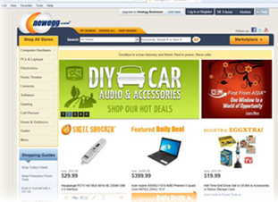

In the above example, we are “window shopping” on a popular technology vendor web site called newegg.com. Note what the address bar reads at the top: http://www.newegg.com. This means the site offers no security presently; no sensitive information is being exchanged at this time.

When we decide on an item to procure, most web sites (like newegg.com) will request for the purchaser to sign in (some sites will offer an opt-out area for this, but many do not). IF YOU CREATE AN ACCOUNT ON THESE SITES, DO NOT USE THE SAME PASSWORD AS YOU WOULD USE TO ACCESS YOUR E-MAIL. Note the address bar has now changed to read https:// and a lock appears in the browser as well (at least with Internet Explorer).

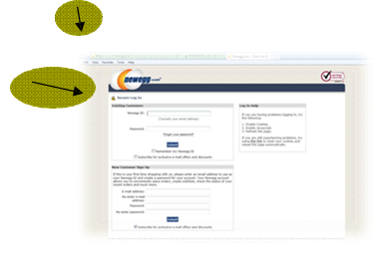

Clicking on that lock reveals information about the web site and its security.

This tells the consumer that this web site has been verified as who they say they are and that the connection is encrypted (we are no longer just “window shopping”). VeriSign and a handful of other similar companies are the Internet’s certificate authorities (CA), which substantiate the identities of companies on the web. By viewing the certificate (which is how the web browser on your computer knows to trust the web site it is displaying), you can see its validity and when it expires. Once that certificate expires, your web browser will alert you that the site is no longer trusted as it once was (this should rarely happen with the big-name sites). Note that web sites that request any form of identification (like logging into a webmail, bank, or paystub account) or financial transaction should use https:// and certificates.

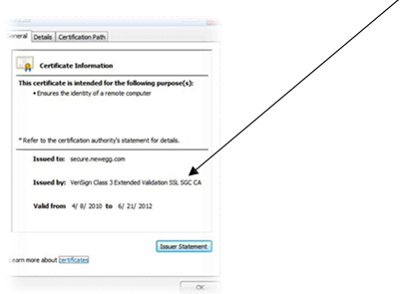

When it comes time to actually buy an item online, a credit card offers the best peace of mind available. Most of the major credit card companies offer “zero liability protection” for unauthorized purchases (read the fine lines carefully, MasterCard states on its web site that one’s account must be “in good standing,” the consumer “exercised reason- able care in safeguarding” the card from unauthorized use, and that there must not be more than two unauthorized events reported in the past twelve months). While the legal verbiage may present a chill, many issuers offer temporary credit card numbers specifically for use online (Citigroup calls their “Virtual Credit Card” while Bank of America markets it as “ShopSafe”). These temporary credit card numbers expire quickly or have whatever transaction limit you wish to assign. When it is time to purchase an item from an online merchant, open another web browser, log into your credit card issuer’s web site, and look for the section to open the tool for a virtual credit card.

This virtual card number appears and functions as an authentic credit card to the vendor; its purpose is to keep its use limited to that particular transaction and to keep your actual credit card number a secret from that vendor. If the virtual credit card is compromised by an unscrupulous third party, it is not as much of an intrusion into one’s financial existence as if the actual credit card number was used (there is no need to replace a credit card, change accounts, etc.) Using this tool satisfies the card issuer’s requirement for “exercising reasonable care in safeguarding” the authentic credit number, limits the amount of uses it can be tried (usually just once), and makes online shopping less frightening. The web may present dangers, but using your savvy skills and online tools should take the fear out of shopping!

